Distributed/ Decenteralized (developers not need to work on the same network) Version control system

Coordinate work between developers

Who made change and what changes did

Revert back at any time

Local and remote repos

For pushing in the remote repository we need net connection

Basic commands:

|  |  |  |
| --- | --- | --- |
|  |  |  |
|  | git init | Create a local repository -> .git folder and it is hidden |
|  | git add <file> | Add files to index |
|  | Git status | Checking the working tree and staging area path |
|  | Git commit | Store it in the local repository |
|  | Git push | Push to the Remote repository |
|  | Git pull | Pull the latest repository |
|  | Git clone | Clone repository in to a new directory |
|  | Git config –global user.name ‘Sibi’ |  |
|  | Git config –global user.email ‘Sibi.ksc@gmail.com’ |  |
|  | git add . |  |
|  | :wq |  |
|  | Git branch <name of the branch> |  |
|  | Git rebase |  |

Adding ssh key you don’t need to enter the password for git hub

Open git bash here

Touch index.html

Touch app.js

|  |
| --- |
| Git config –global user.name ‘Sibi’ |
| Git config –global user.email ‘Sibi.ksc@gmail.com’ |

Git add index.html

Git status

Git rm –cached index.html --🡪 both the index.html and app.js will be untracked

Git add *.html 🡪 add all the html extension files

* All html extension files are tracked

Git rm - - cached index.html

Red hat container Development kit 3.10

how to build custom Docker images,

how to deploy an application with OpenShift Source-to-Image feature,

how to expose an application with a route,

and finally we’ll do a quick demonstration of the OpenShift Web Console

Containerized application:

any updates or patches applied to the base OS might break the application

Eg:

Devops cicd pipeline setup:

Services:

Git

Buid –maven

Ansible’

Jenkins - build

J unit – testing

Sonar cube – to monitor

**Simple cicd pipeline:**

Developer commit the code in git

Buid and test using Jenkins

Deploy in the Amazon Ec2 – nothing but deploying in a VM

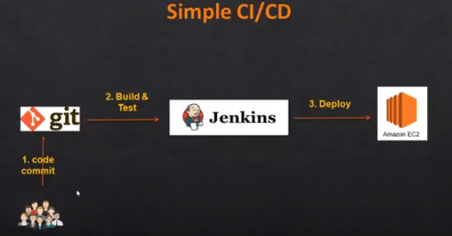

Introducing Ansible in CICD

Ansible will do the deployment – we want to install the apache

Introducing Nexus in CICD:

Nexus – Store artifacts

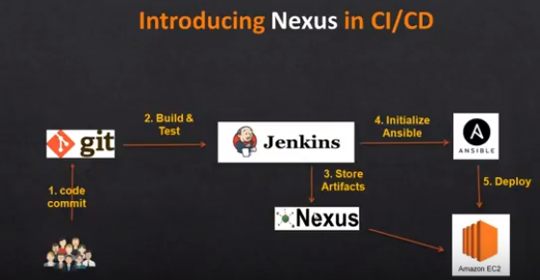

Introducing SonarQube in CICD

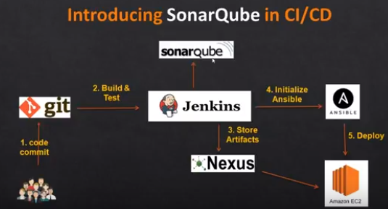

SonarQube will review the code and do static analysis and it is helpful for developer

Introduction Docker in cicd:

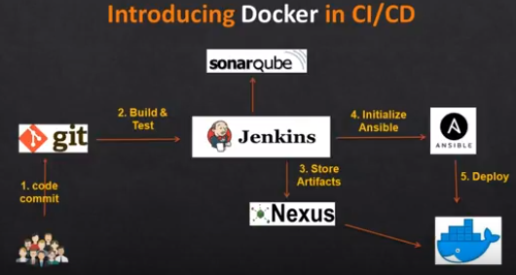

Deployment in docker file or docker images

Introduction Kubernetes in CICD

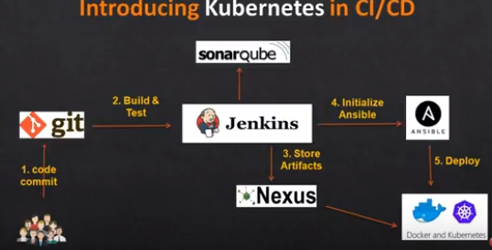

Will create a kubernetes cluster, by using docker images to deploy it as parts

Introduction to Nagios in CICD:

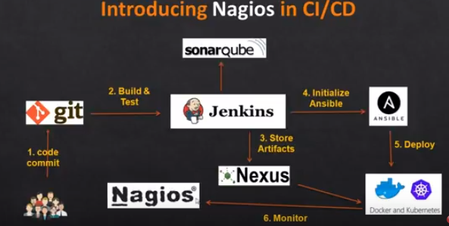

**Pre-requisites to start with simple ci/cd**

Git – commit the code

Jenkins – Build and test

Amazon EC2- deploy

1. GitHub account
2. any project
3. AWS account
4. Jenkins server
5. Maven and git installation and configuration
6. Tomcat server

Later learn how to create github server in AWS